APPENDIX 1

LUDO GAME USING GUI AND
RANDOM NUMBERS

END TERM REPORT

by

- Names of Candidates: R.Sathvik Reddy,Anu Dhatterwal,Rucha

- Section: K19PT

- RollNumbers: 12,41,64


Department of Intelligent Systems,
School of Computer Science Engineering,
Lovely Professional University, Jalandhar
November, 2020

APPENDIX 2

Student Declaration

This is to declare that this report has been written by R.sathvik Reddy,Anu,Rucha. No part of the report is copied from other sources. All information included from other sources have been duly acknowledged. We aver that if any part of the report is found to be copied, we are shall take full responsibility for it.

Signature:sathvikreddy
Name:R.sathvik Reddy
Roll Number:12

Place: ALER,TELANGANA
Date: 31/10/2020

APPENDIX 3

TABLE OF CONTENTS

TITLE PAGE No

1. Background and objectives of project | 1
1.1 Introduction............................................................... | 1
1.2 Objective…................................................................ | 1
2.Description of Project
2.1 Description.................................................................. | 2
2.2 Functionalities…........................................................ | 3
APPENDIX 4

BONAFIDE CERTIFICATE

This is to certify that dissertation entitled “Ludo Game Using GUI and Random Numbers” submitted by R.SATHVIK REDDY(K19PT12),ANU(K19PT41),RUCHA(K19PT61) in partial fulfillment of the requirement for the award of degree of bachelor of technology in Computer Science and Engineering at Lovely Professional University,Punjab is record of bonafide work carried out by his under supervisor from August 2020 to October 2020.The results presented in this dissertation have been verified and are found to be very satisfactory.The results embodied in this dissertation have not been submitted to any other university for the award for any other degree

Signature of the Supervisor(Due to Covid 19, signature is exempted )
Dr.Dhanpratap Singh
ID:25706
Computer Science and Engineering

Introduction:
Ludo Game using GUI and Random Numbers project is a simple Application, which can take the input from the user and runs based on operating system with user input and generate the random output in the form of random numbers by throughing the dice.
This project is mainly built on a python GUI package called Tkinter. There are various other module is used in this project like OS, RANDOM to improve the ability of the project and make it much more interactive.
Tkinter is a Python binding to the Tk GUI toolkit. It is the standard Python interface to the Tk GUI toolkit, and is Python's de facto standard GUI. Tkinter calls are translated into TCL(High Level Dynamic programming language) commands which are fed to interpreter.

Objective:
The main objective of this project to generate the random number on dice by ever through on by the user.it takes the inputs from the user consists of computer and human option with that it consider the number of players with different number of colors.
This application is easy to use, and there is no complex option or no complex coding. This app is based on OOP(Object Oriented Programming) concept. It is built on using simple user define function. This app is very simple to use.

Description: This project consists of python file which is game.py and run.py some associated file is there like one font file to show the ludo game. which process the total game in the command prompt and generate the random numbers on dice as follows.
When we click on run.py file, the output will be generated as follows.

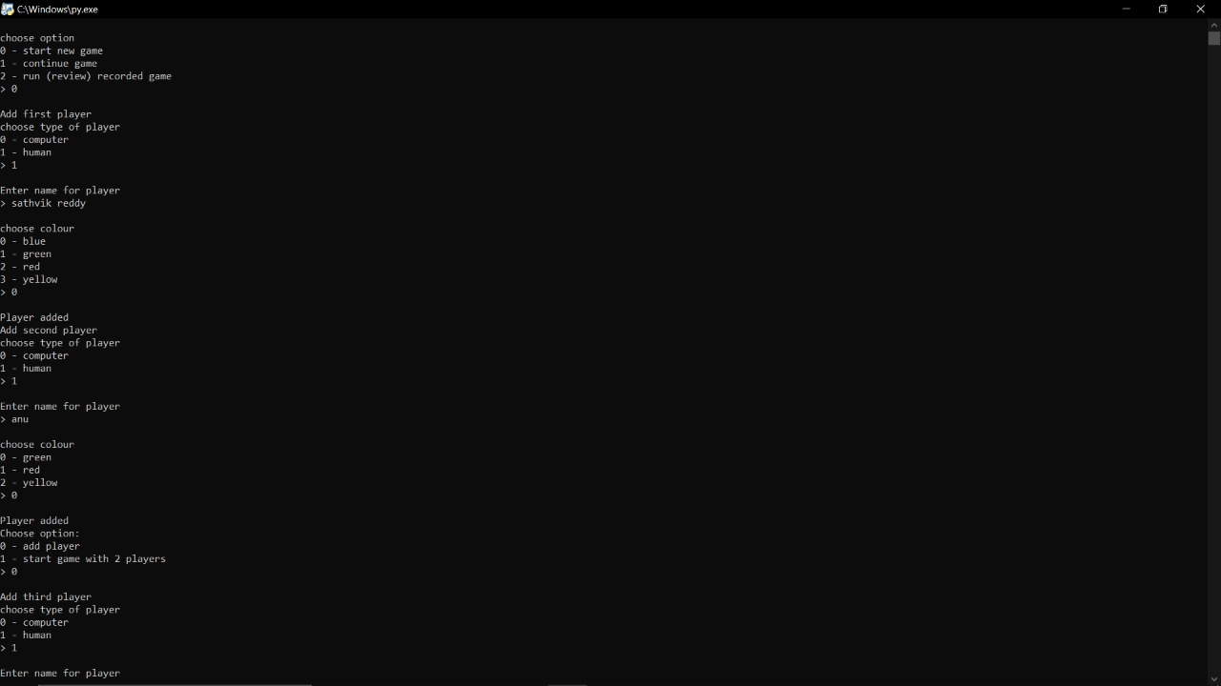

The command prompt explains us about the whole proccess of selecting the computer and human with different colors and with names of the users.

Thus the addition of users and their colors are as follows

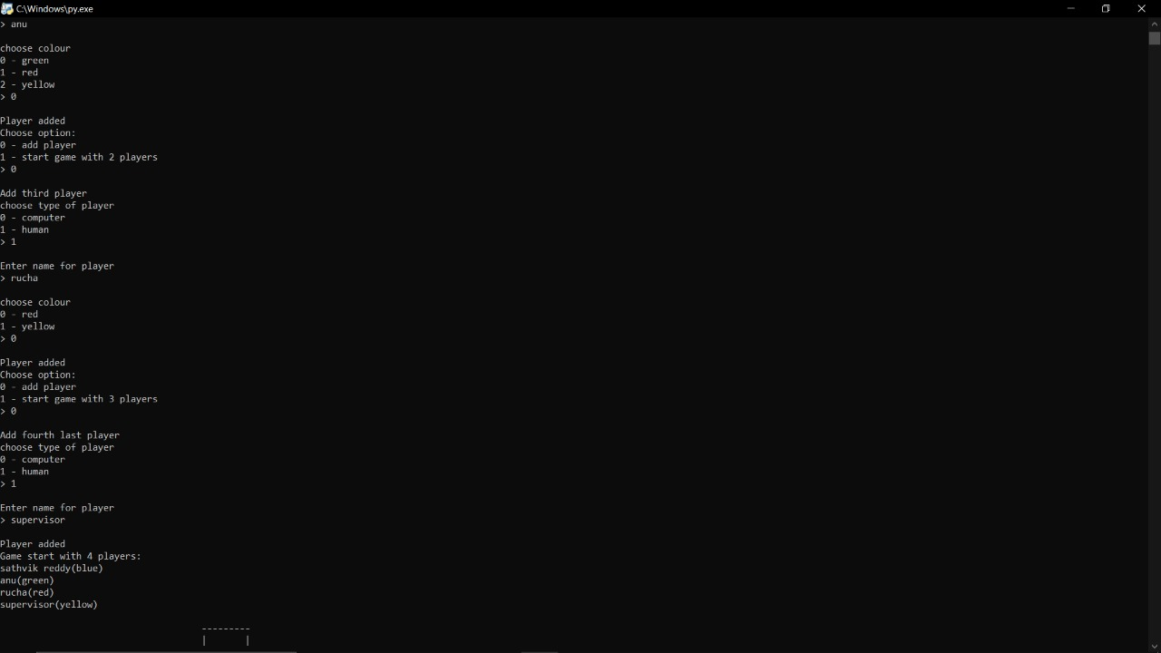

By the end all the users are added and the game starts from here which generate random numbers on dice.

The Ludo Board will appear as follows with different players with different colors:

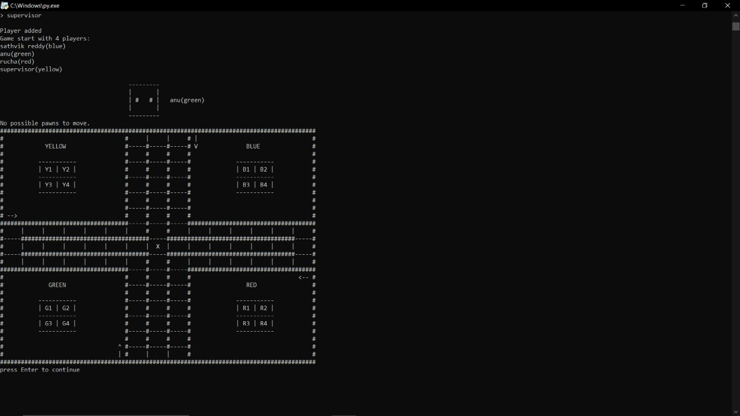

Functionalities:

Thus the whole process will take place on generating the random numbers on dice.finally the players who got 6 as the number on dice will get another chance for the through of dice, thus the whole procces will continue as above mentioned

